

**Final Project Report**

**（ 2017 / 2018 1st Semester）**

|  |  |
| --- | --- |
| **Course** | Software Engineering |
| **Project** | Mobile Application |
| **Date** | 2017.12 |
| **School** | School of Computer Science |
| **Teacher** | Zheng Liu |

|  |  |  |  |
| --- | --- | --- | --- |
| Group-3 | EMMANUEL KORANTENG  ISAAC MOUKASSA  MARUF | ID | F15040112  F15040111  F15040103 |
| School | OVERSEAS COLLEGE | Major | COMPUTER SCIENCE |

**Report.**

|  |
| --- |
| **Purpose and Requirement:**   * To build a working software project (ANDROID SCHEDULING APP). * To get familiar with git hub. |
| **Environment**   * Android studio. * Java language. |
| **Project Summary:**  We build a working scheduling app that comes with the following functions;   1. Allows users to set several tasks as needed. 2. Saves users data (task). 3. Allows users to set time to each task. 4. Notifies user with a notification pop up message and alarm. 5. Gives users the option to delete an accomplished Task.   Procedure/Steps:   * We first did our research on android studio after wording on project proposals and requirements including project classes and sequence diagram . * After we came up with a simple UI for the application. * Then started working the coding. * Finally did testing and application execution. |

**UI Diagrams:**

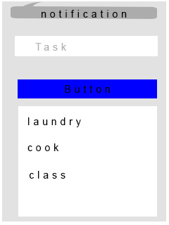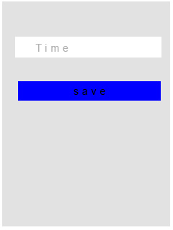

**Code: uploaded to Git hub**

**Output:**

**Video demonstration in ppt file and also sent to email.**

|  |  |  |  |  |  |
| --- | --- | --- | --- | --- | --- |
| **Conclusion:**  After the project we have developed in skills in our course and learned a lot, we now have the experience and skill in software engineering and building basic software applications. | | | | | |
| **Advisor Comments** | | | | | |
| **Score** |  | **Teacher** |  | **Date** |  |